📊 Sector-Specific Executive Decks
Mohammed Al-Ojaimi Energy Services – Automation Department

🏭 DECK 1 — Industrial Factories
Digital Operations Backbone for Large-Scale Manufacturing
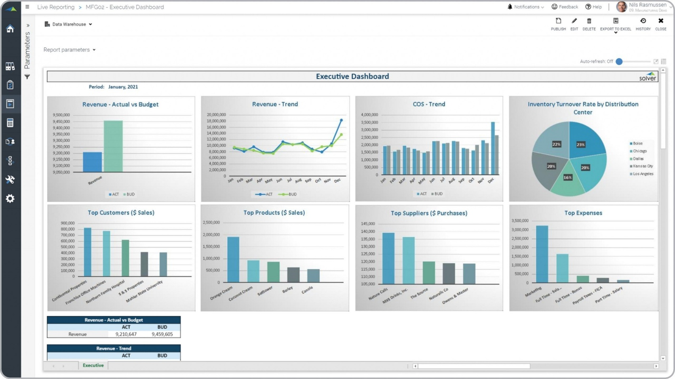
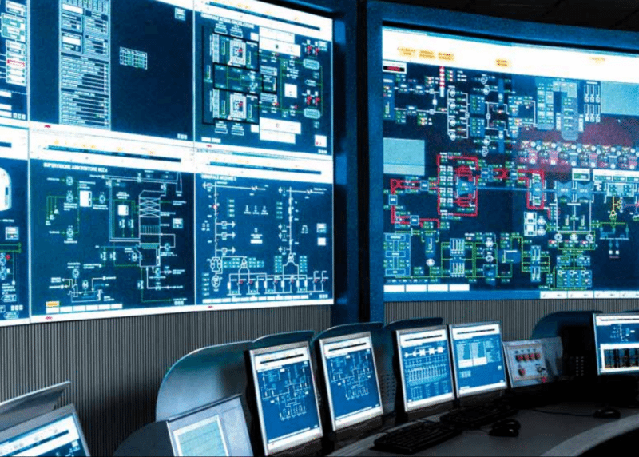
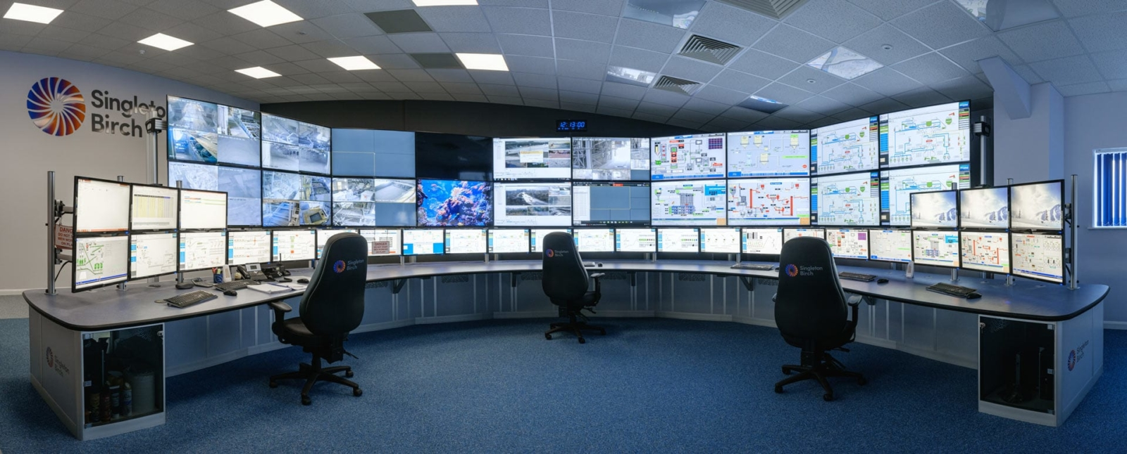
4
Slide 1 — Executive Hook
From Production Lines to Profit Visibility
Utility-grade automation for factories that cannot afford inefficiency.

Slide 2 — Manufacturing Executive Pain
- OEE loss hidden across lines
- Downtime discovered too late
- Energy cost per unit unknown
- Multiple OEM islands
- Expansion without standardization

Slide 3 — Strategic Shift
From Line Automation → Factory Operations Intelligence
Factories don’t fail due to PLCs.
They fail due to lack of operational visibility.

Slide 4 — Solution Overview
Plant-wide SCADA + analytics platform built on COPA-DATA zenon, integrating:
- Production
- Utilities
- Energy
- Maintenance signals

Slide 5 — Executive KPIs
KPI | Impact
OEE | +5–12%
Downtime | −30–50%
Energy Cost / Unit | −10–15%
Maintenance OPEX | −20–30%

Slide 6 — ROI Logic
- Downtime avoidance = immediate cash impact
- Energy optimization = recurring savings
- Standardization = scalable expansion

Slide 7 — Ideal Project Profile
- Budget: 7–20+ M SAR
- Clients: FMCG, food & beverage, cement, steel
- Duration: 9–18 months

Closing Slide
This platform pays for itself by revealing what your factory is already losing.

🏥 DECK 2 — Medical Facilities & Medical Cities
Clinical Operations Continuity Platform
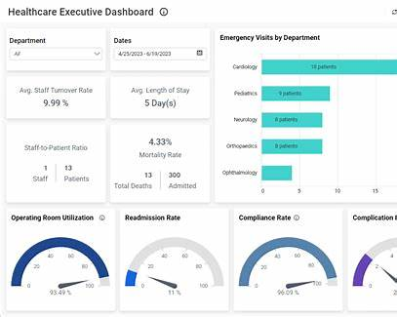
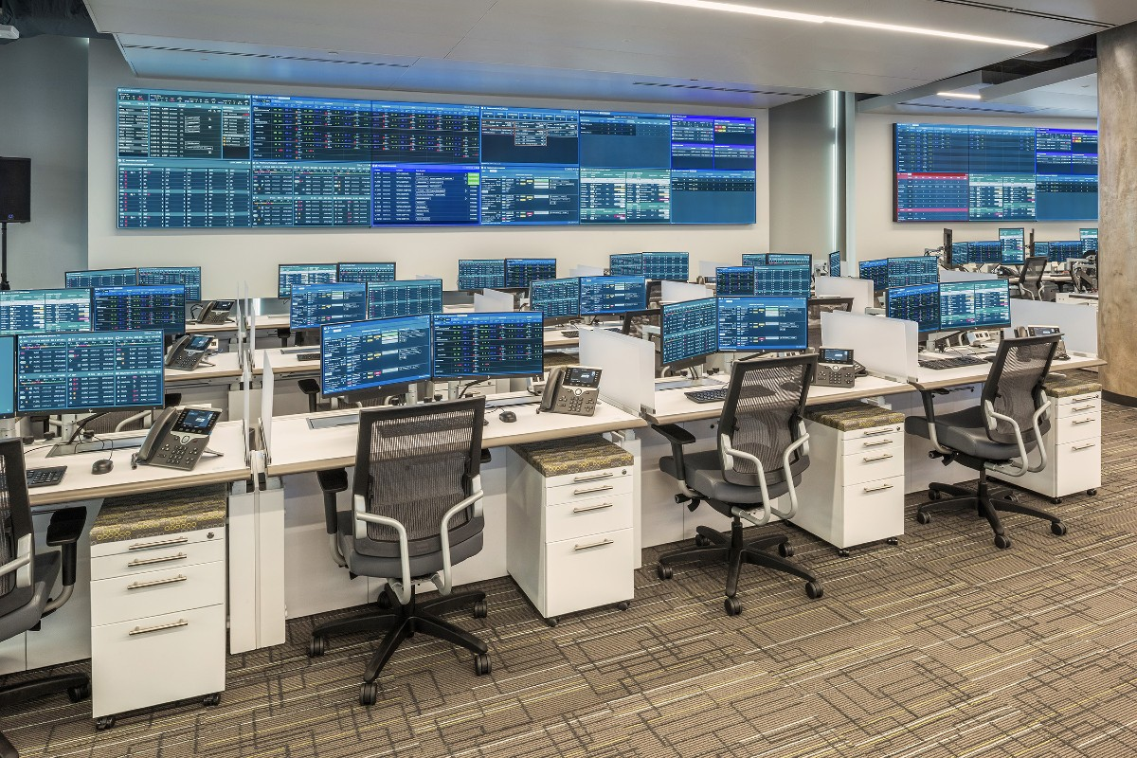

4
Slide 1 — Executive Hook
When Infrastructure Fails, Patient Care Is at Risk

Slide 2 — Healthcare Executive Reality
- Zero tolerance for downtime
- Fragmented infrastructure systems
- Alarm floods with no clinical context
- Rising energy and compliance pressure

Slide 3 — Strategic Shift
From Facility Monitoring → Clinical Operations Assurance
Hospitals require utility-grade reliability, not building automation.

Slide 4 — Integrated Hospital Platform
Single command platform integrating:
- Power & backup systems
- HVAC & clean rooms
- Medical gases
- Energy & sustainability KPIs
- Alarm escalation logic

Slide 5 — Executive Outcomes
Area | Result
Infrastructure Availability | >99.99%
Alarm Response | −40–60%
Energy Cost | −10–18%
Emergency Readiness | Continuous

Slide 6 — Risk Mitigation Value
- Patient safety protection
- Regulatory compliance readiness
- Disaster-scenario preparedness
- Executive-level visibility

Slide 7 — Ideal Project Profile
- Budget: 8–25+ M SAR
- Facilities: Medical cities, university hospitals
- Engagement: EPC / PMC aligned

Closing Slide
This is not automation — it is patient-care risk insurance.

🏢 DECK 3 — Mega Buildings & Data Centers
Enterprise Operations Intelligence Platform
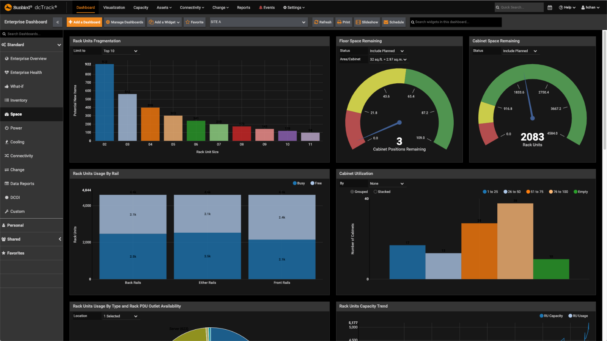
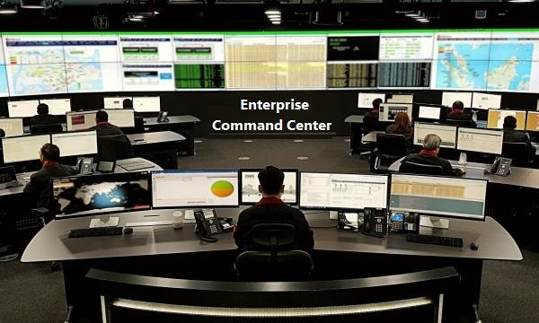
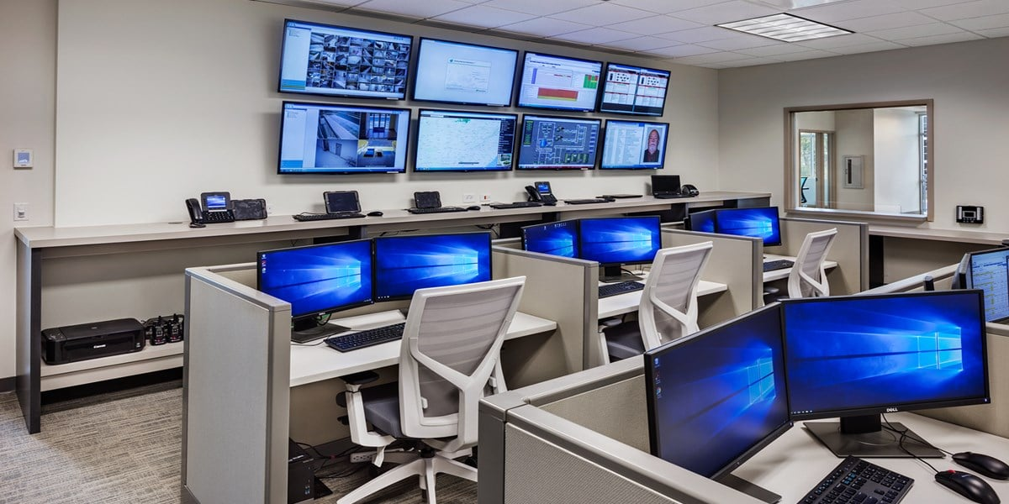
4
Slide 1 — Executive Hook
Downtime Is Not a Technical Issue — It’s a Business Failure

Slide 2 — Enterprise Facility Pain
- Disconnected BMS / PMS / DCIM
- No portfolio-level visibility
- Alarm noise instead of insight
- Energy inefficiency at scale
- Vendor lock-in risk

Slide 3 — Strategic Shift
From Smart Buildings → Continuously Operated Assets

Slide 4 — Enterprise Command Platform
Unified operations layer integrating:
- Power & redundancy
- Cooling & HVAC
- Energy & ESG metrics
- Incident and SLA visibility
- Multi-site governance

Slide 5 — Board-Level Metrics
KPI | Impact
Facility Availability | >99.99%
Energy OPEX | −10–20%
Incident Response | −40–60%
Alarm Noise | −50–70%

Slide 6 — Financial Justification
- SLA penalty avoidance
- Energy optimization ROI
- Portfolio standardization
- Long-term lifecycle savings

Slide 7 — Ideal Project Profile
- Budget: 10–50+ M SAR
- Assets: Data centers, airports, HQs, campuses
- Timeline: 12–24 months

Closing Slide
Your facilities should behave like infrastructure — not buildings.

